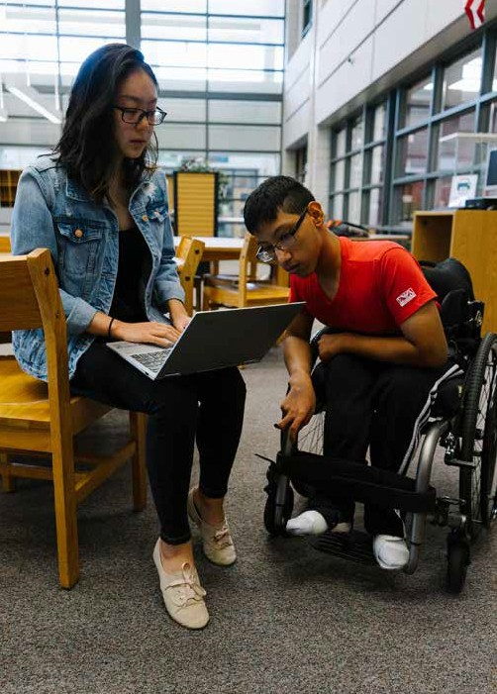

™

LEARN TO CODE FROM HOME
FREE, SUMMER CODING PROGRAM LEARN HTML, CSS, AND JAVASCRIPT

CREATE YOUR OWN WEBSITES AND APPS

JUNIOR AND HIGH SCHOOL STUDENTS INVITED TO PARTICIPATE

ONLINE MENTORS AVAILABLE

